Ayush Sharma 12 March 2018

(150123046)

Question 1.

Plot of the prices against time (daily, weekly and monthly).

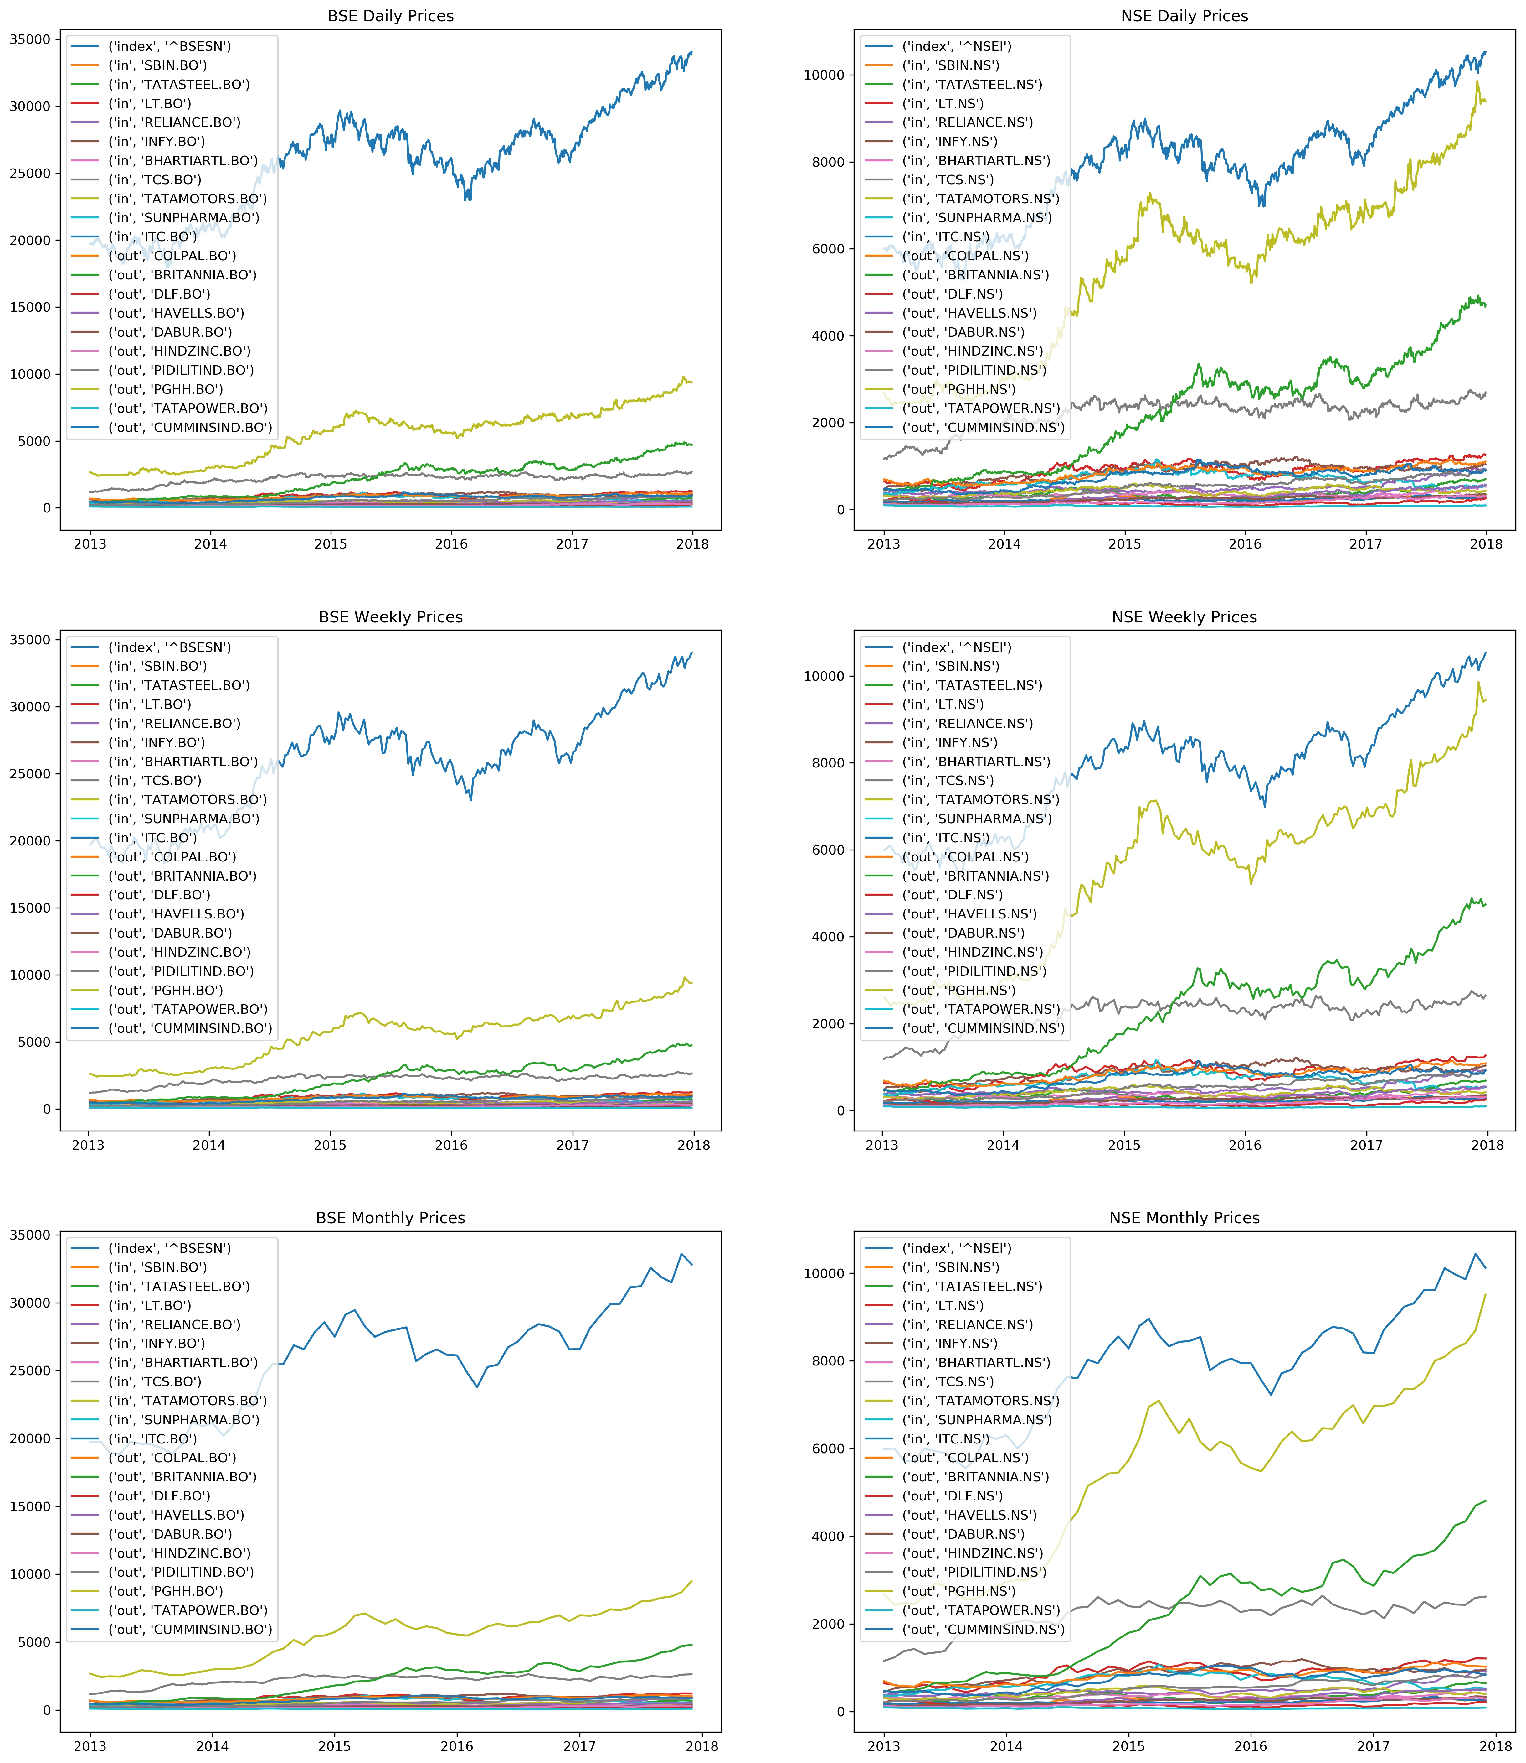

Question 2.

Histograms of the normalized returns (daily, weekly and monthly).

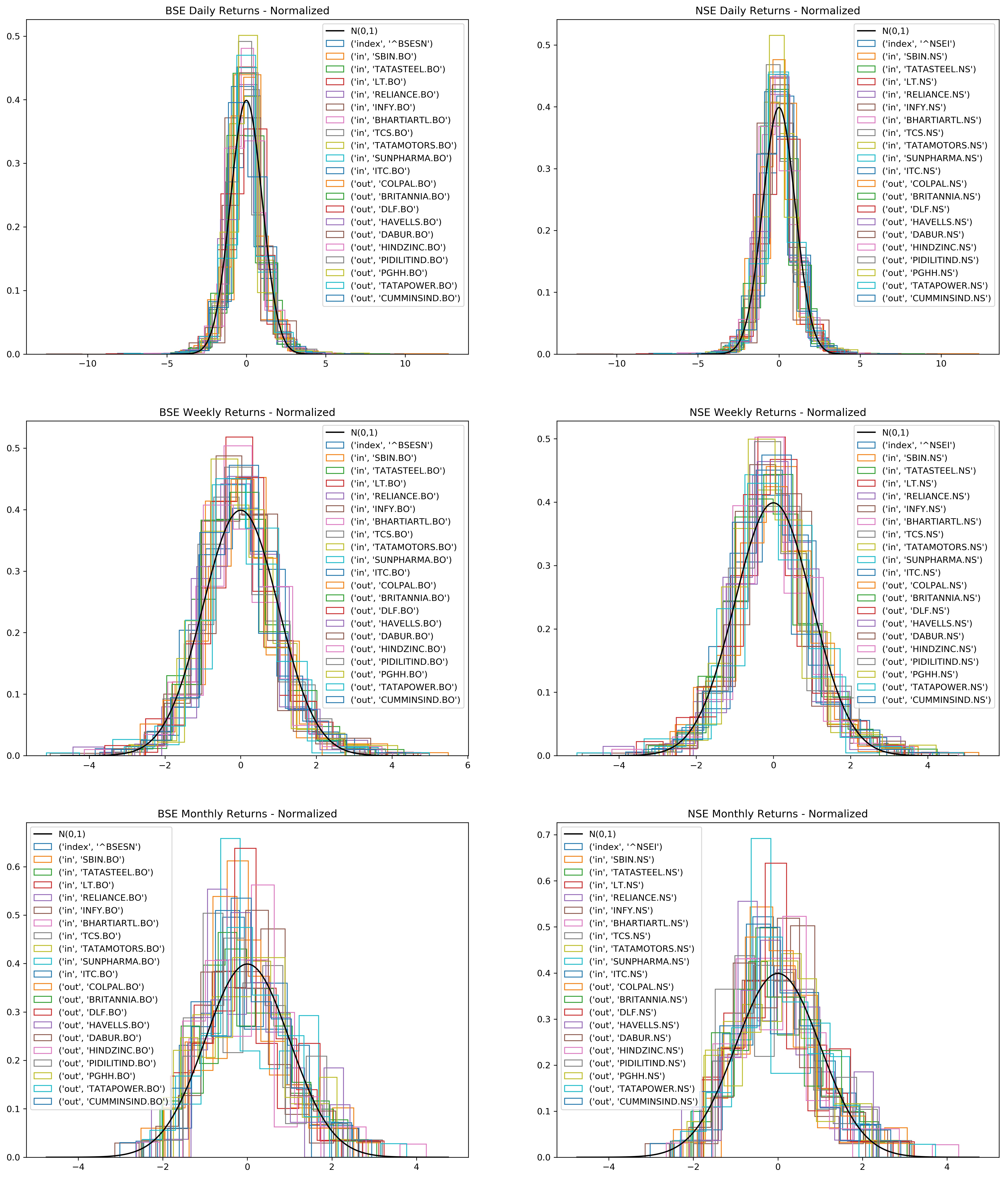

Zooming into the tails of these plots, significant presence of outliers is observed, rendering the assumption of returns being normal incorrect.

Question 3.

Histograms of the normalized logarithmic returns (daily, weekly and monthly).

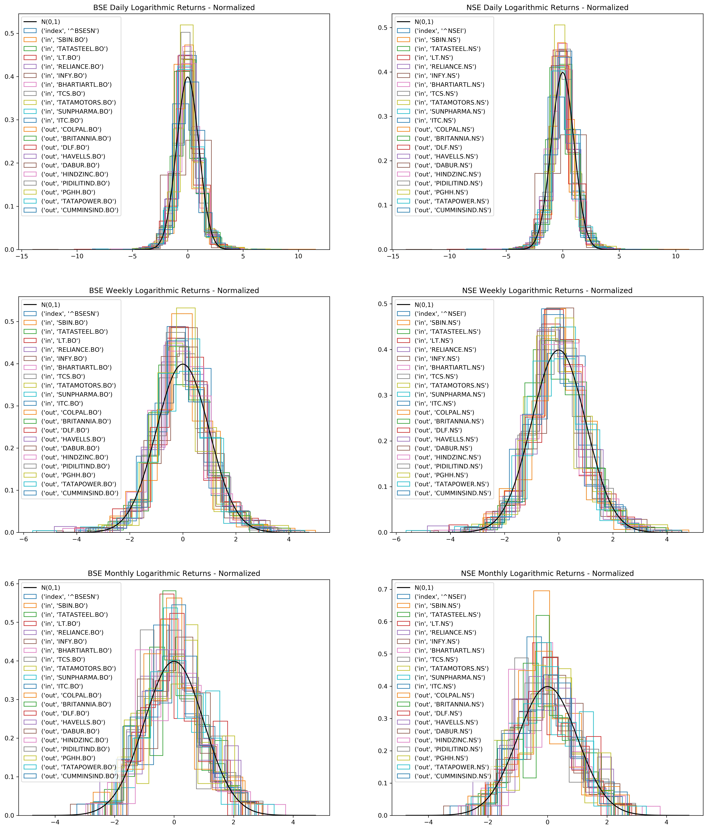

Zooming into the tails of these plots, a little less significant presence of outliers is observed compared to the case of arithmetic returns, rendering the assumption of returns being normal slightly less incorrect.

Or, the logarithmic returns can be taken to be normal with more confidence than the arithmetic returns.

Question 4.

Consider the daily data only for the period January 1, 2013 to December 31, 2016 and estimate the $μ$ and $σ$ using log returns.

Using the $μ$ and $σ$, generate a path of stock prices that resembles (as closely as possible) the actual path of the stock for the period of January 1, 2017 to December 31, 2017.

Question 5.

Repeat the above with weekly and monthly data.

Simulated Prices.

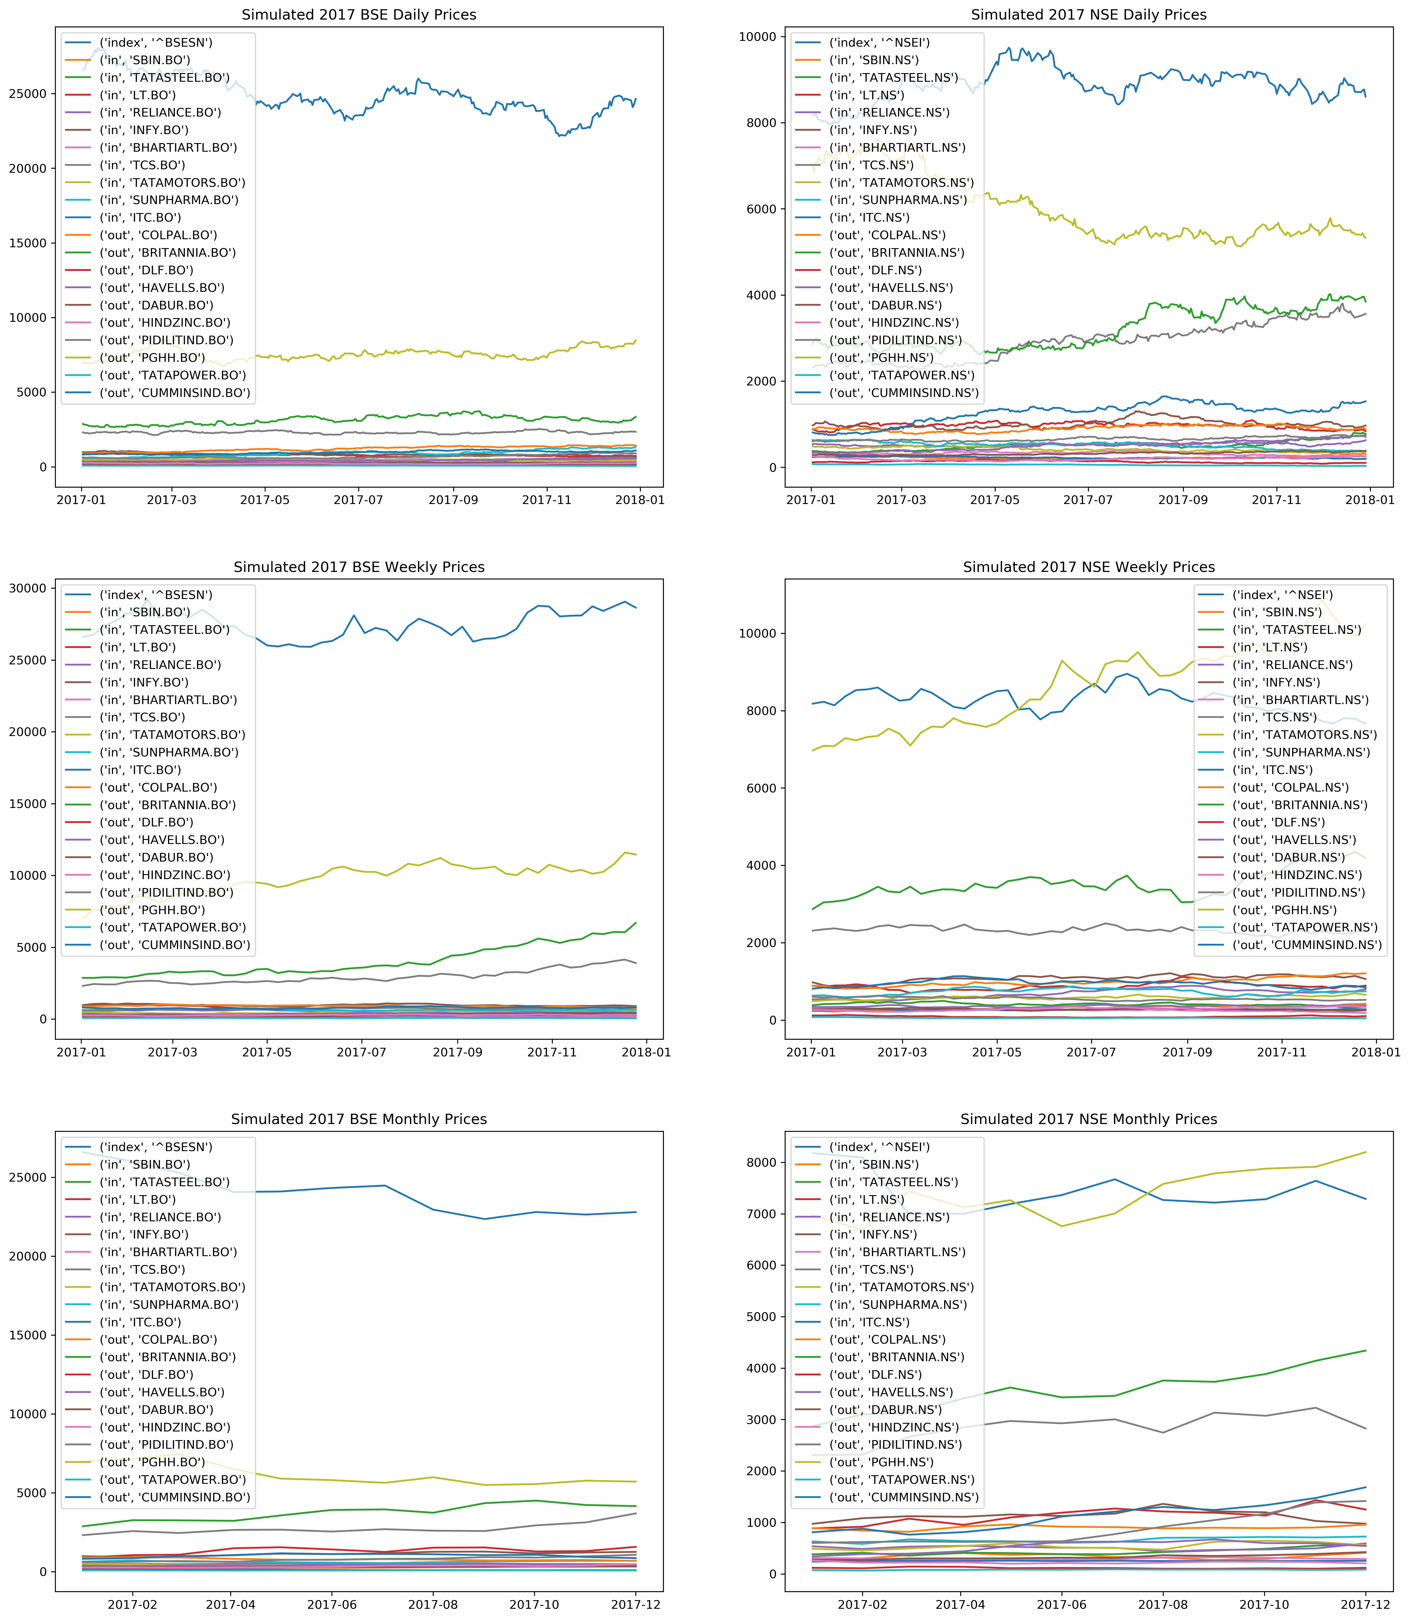

Actual Prices.

